**Problem 2: Image segmentation using EM**

You can segment an image using a clustering method - each segment is the cluster center to which a pixel belongs. In this exercise, you will represent an image pixel by its r, g, and b values (so use color images!). Use the EM algorithm applied to the mixture of normal distribution model lectured in class to cluster image pixels, then segment the image by mapping each pixel to the cluster center with the highest value of the posterior probability for that pixel. You must implement the EM algorithm yourself (rather than using a package). Test images are here, and you should display results for all three of them. Till then, use any color image you care to.

1. Segment each of the test images to 10, 20, and 50 segments. You should display these segmented images as images, where each pixel's color is replaced with the mean color of the closest segment

**Answer:**

Three images are read into R and for each pixel RGB digits are ordered in an array with three columns. The raw pixel RGB data are then fed into a k-mean()  function and center of clusters are obtained as the starting point for various segments mean values. In the next step the EM loop is generated using a repeat {} loop. The criteria for breaking the loop has been determined as [mean((πnew−πold)2)] < 10e-9 . In order to avoid numerical problems in the implementation, the square distance to the center of the closest cluster ( d2min) is subtracted during E step as shown in below formula (Forsyth D.A, 2017):

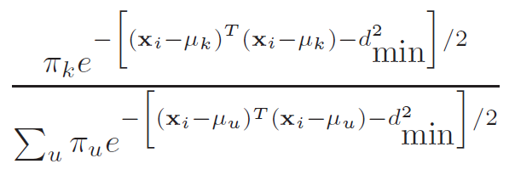

After calculating the wij parameters (W matrix) during the E step. The Pn+1 and mn+1 are then calculated in the M step and the iteration is looped till the convergence criteria is reached. As the EM process is converged, each pixel is replaced with the mean of cluster to which it is closest too and therefore segmented into definite numbers of clusters. As requested by the problem, this process is performed for three various numbers of segments for which results are included in the followings.

According to the results, the fewer number of segments are used for image segmentation, the more images are murky with less variety of colors. The images segmented using 50 segments, has the most resemblance to the original picture which is expected, though the EM model takes longer for converging in case of image segmentations with higher number of segments.

**a (Original Image) b (Segmented Image in 10 segments)**

 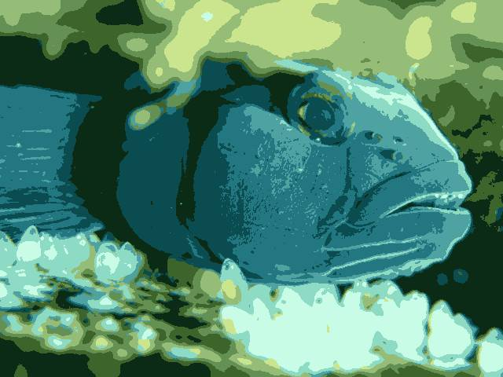

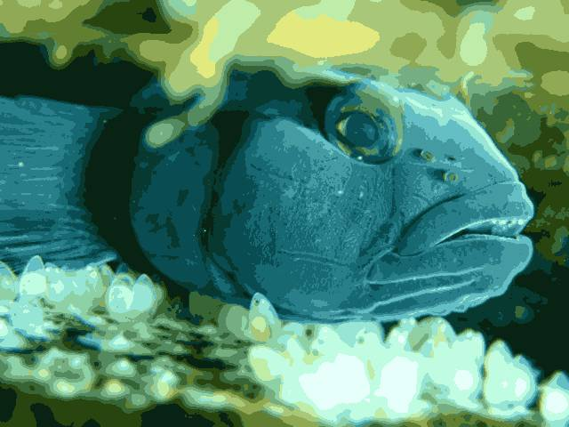 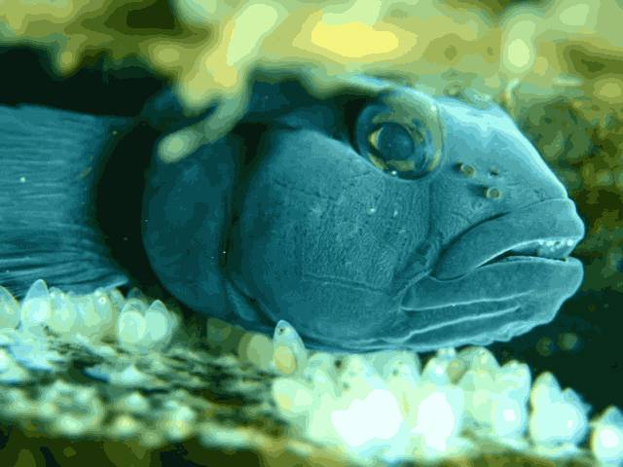

**c (Segmented Image in 20 segments) d (Segmented Image in 50 segments)**

**a (Original Image) b (Segmented Image in 10 segments)**

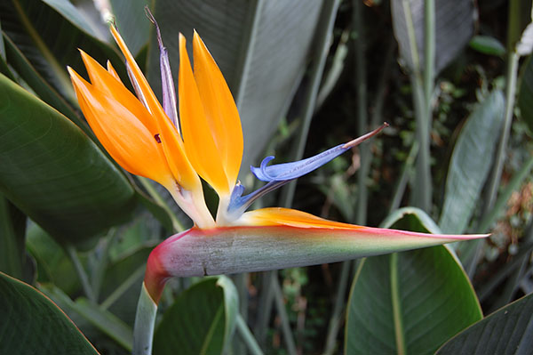 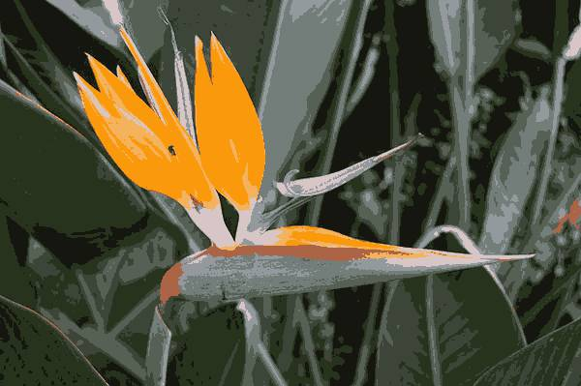

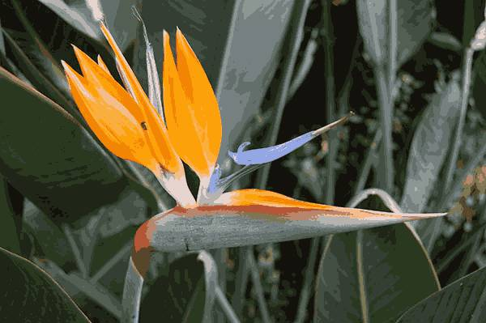 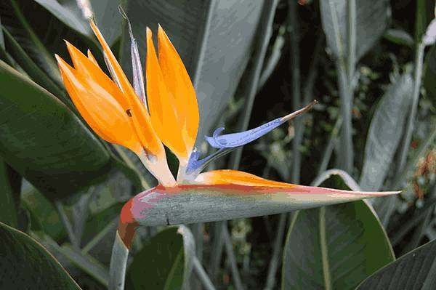

**c (Segmented Image in 20 segments) d (Segmented Image in 50 segments)**

**a (Original Image) b (Segmented Image in 10 segments)**

 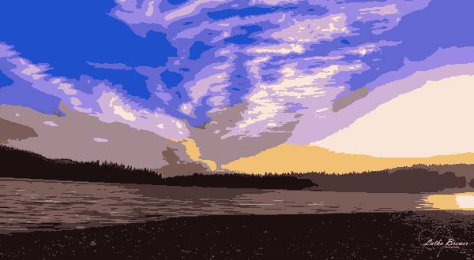

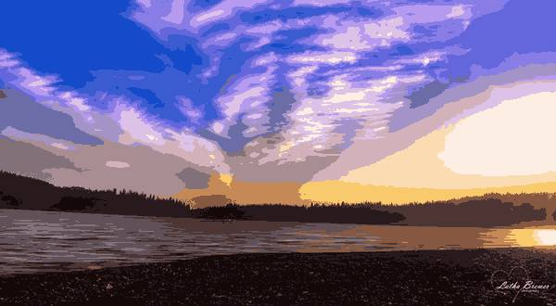 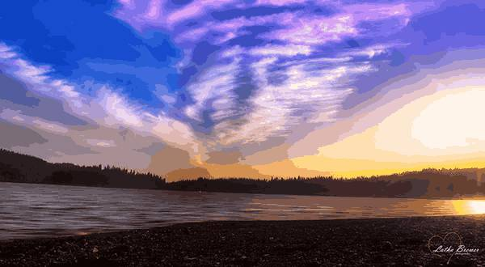

**c (Segmented Image in 20 segments) d (Segmented Image in 50 segments)**

1. We will identify one special test image. You should segment this to 20 segments using five different start points, and display the result for each case. Is there much variation in the result? **The test image is the sunset image**

**Answer:**

For this task the Sunset Image is chosen and segmented into 20 different segments using EM algorithm. The EM image segmentation is done for 5 times, each one with different starting points. The code for previous tasked is tweaked for this task, however, the foundation principles such as trick for avoiding numerical problems and convergence criteria is kept the same. Regarding the starting mean values, 5 various sets of mean values are calculated according to the mean values collected from the k-mean cluster centers. The starting mean sets are k-mean cluster centers as well as 10%, 55%, 145% and 190% of the k-mean cluster centers. The five image results are provided in the following.

The results images are presented in the following. In general, I believe the images had significant variation and it can be concluded that the EM algorithm is dependent on the starting points. The images with respectively small and similar values of starting points are converted to mono-color or bi-color images. That is, as the starting points of various segments get closer to each other, the resulting clusters (segments) obtained after convergence of EM algorithm are closer and more similar to each other as well. This results in clustering and segmentation of pixels being performed less accurately as pixels will be accumulated into specific segments and some segments will be empty. Therefore, less segments are technically generated, and less variety of colors will be used for the modified images.

**Starting with mean values 190% of the ones obtained from K-mean analysis**

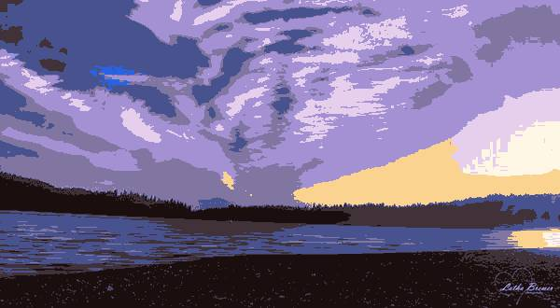

**Starting with mean values 145% of the ones obtained from K-mean analysis**

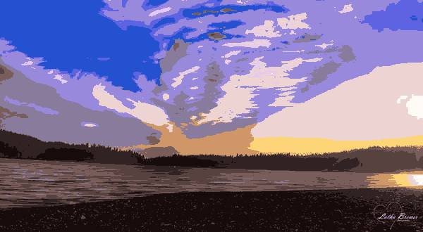

**Starting with mean values similar to the ones obtained from K-mean analysis**

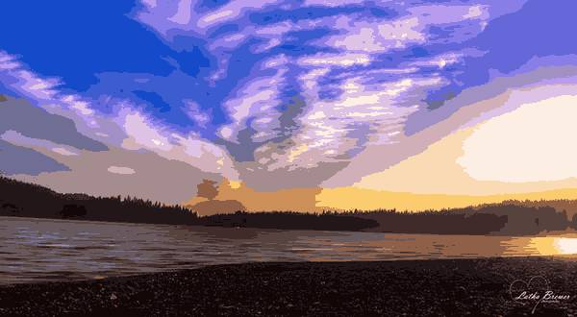

**Starting with mean values 55% of the ones obtained from K-mean analysis**

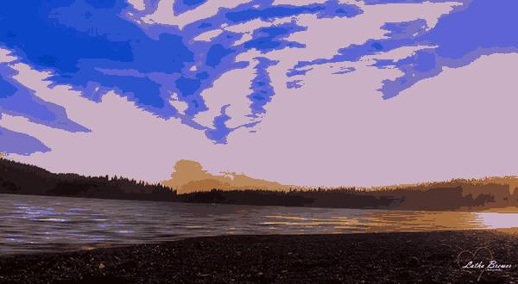

**Starting with mean values 10% of the ones obtained from K-mean analysis (near 0)**

